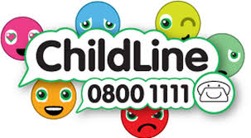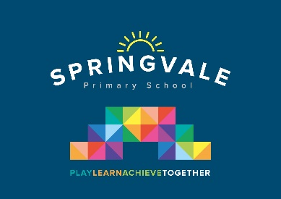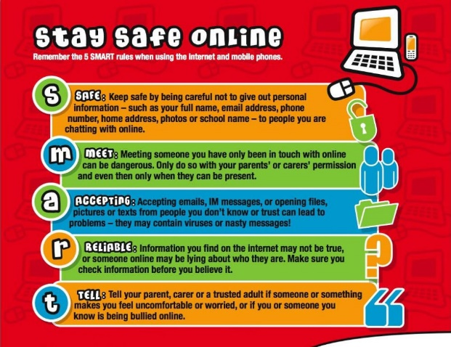

|  |  |
| --- | --- |
| **Learning Project WEEK 3- Viewpoints** | |
| **Age Range:** EYFS  FS2 The Curious Cubs | |
| **Weekly Maths Tasks (Aim to do 1 per day)** | **Weekly Reading Tasks (Aim to do 1 per day)** |
| * Watch a Numberblocks clip each day at: [BBC](https://www.bbc.co.uk/iplayer/episodes/b08bzfnh/numberblocks?page=2) or [CBeebies](https://www.bbc.co.uk/cbeebies/shows/numberblocks). Use this guide [here](https://www.bbc.co.uk/cbeebies/joinin/numberblocks-help-your-child-with-maths) to give you ideas on what to do with your children whilst watching an episode.   Watch Thirteen (series 3) to introduce 13. Collect 13 objects. Take one away so that you have one less. How many do you have now? Make 13 again and add one more object. How many do you have now?   * Practise counting up to 20 and back again. This can be done through playing hide and seek, singing number songs, chanting, board games etc. * Play the Numberblocks pattern spotting [game](https://www.bbc.co.uk/cbeebies/puzzles/numberblocks-easy-patterns-quiz?collection=numbers-and-letters). * Explore making patterns in a variety of ways. Use blocks to make a red block, green block, red block….pattern. Can your child continue it? * Use 3D shapes or objects to press patterns into dough. * You could arrange their snack in a repeating pattern. Encourage your child to describe it. They could then make a pattern of their own. * You could also share some stories that have patterned language, such as, We’re Going on a Bear Hunt by Micheal Rosen. Encourage your child to build their own Bear Hunt outside and repeat the patterned language or invent language patterns of their own. | * Read a variety of books at home. Favourites can be repeated. Hearing the patterns of language in a story will support your child’s language development. * Reception age children: Children to read to parents daily. Visit Oxford Owl for free eBooks that link to your child’s book band. You can create a free account at: <https://www.oxfordowl.co.uk/for-home/>   Complete the linked Play activities for each book.   * With your child, look in magazines, newspapers and books for the tricky words they are currently learning. They could use a highlighter to highlight in magazines and newspapers. |
| **Weekly Phonics Tasks (Aim to do 1 per day)** | **Weekly Writing Tasks (Aim to do 1 per day)** |
| Our children are all in very different places for learning sounds. Please ask your child which adult they work with for phonics and focus on these sounds  Mrs Cliffe/Mrs Honey and Mrs Parr  Sound of the week: th  Read and spell words such as bath, moth , thin, with, path  Mrs Slack/Mrs Gale/Mrs Evans  Sound of the week igh  Read and spell words such as sigh, high, sight, fight, light,   * Daily phonics - Practice the sounds your child is working on and blend words. This can be oral blending (e.g. spoken out loud c-a-t) or written if appropriate. See these [Interactive games.](https://www.phonicsplay.co.uk/)   On phonicsplay.co.uk play Dragons Den, read the word on the egg and feed the real and fake words to the dragons.  On Forest Phonics (ictgames.com) you can practice building words using this weeks sound. | * Practice name writing. Can they write their first name? Middle name? Surname? * Practice forming the letters of the alphabet, l i t * Ask your child to write out the tricky words they are working on at the moment on pieces of paper and turn them into a pairs game. * Ask your child to draw or write a shopping list to help plan for the weekly shop. Encourage them to ask all family members views on what they would like to eat that week. * Ask your child to help plan a movie night/ afternoon. Select two films from a streaming service or DVD’s you have in the house. Ask them to draw a picture to represent each film or write out the title. Ask them to speak to each member of the house to find out their view on which film they would like to watch. Ask your child to write each person’s name under their chosen film. |
| **Learning Project - to be done throughout the week** | |
| **The project this week aims to provide opportunities for your child to learn more about different viewpoints. Learning may focus on physical viewpoints in terms of what you can see outside of the window at home, what others can see looking into your home and then progress onto personal viewpoints and of others.**   * **What can you see out of your window?-**    + Ask your child to look out of a window in the house and draw what they can see. Look out of a different window (e.g. back or side of the house), draw what they can see. Look at the two pictures together and discuss what is the same in both pictures (e.g. the sky) and what is different. * **Record how many cars/ people walk past your house-**   + Set a timer for 5 minutes on your phone or tablet. Draw out a simple grid (as below) and ask your child to put a tick in the right place every time a person or car goes past. When complete, can they count up the ticks and write the matching numeral? Were there more people or cars?      * **How do we differ from others?-**   + Ask your child to look in a mirror at their hair colour, eye colour, skin colour. Ask them to create a self-portrait using either felt-tips, crayons or paint. Look at some pictures in books and magazines. Does everyone look the same way as them? How do people look different? * **Imagine another world outside the window-**   + Close the curtains and ask your child to imagine that the house is in a new imagined world. What do they imagine? Is it snowy? Are there dinosaurs/ monsters in the new world? Ask them to tell you a story about it…   Your child could create a story map to show what happens in their imaginary world (see right).   * **Go on a sight hunt-**   + Support your child to make a viewfinder. Cut out a square of card from an old cereal box/ cardboard. Cut a smaller square out of the centre. Take your viewfinder around the house and garden and explore what things you can see. Alternatively, you could create a pair of binoculars as pictured.   + Your child could write a list of the things they see or draw/ paint a picture.   + If you have a tablet or phone that could be used by your child they could do the same activity but using photographs to record. | |
| **Additional learning resources parents may wish to engage with** | |
| [**Classroom Secrets Learning Packs**](https://classroomsecrets.co.uk/free-home-learning-packs/) **-** These packs are split into different year groups and include activities linked to reading, writing, maths and practical ideas you can do around the home.  [**Twinkl**](https://www.twinkl.co.uk/offer/UKTWINKLHELPS?utm_source=promo&utm_medium=email&utm_campaign=England_coronavirus_schools_email&utm_content=offer_link) **-** to access these resources click on the link and sign up using your own email address and creating your own password. Use the offer code UKTWINKLHELPS.  [**Headteacherchat**](https://www.headteacherchat.com/post/corona-virus-free-resources-for-teachers-and-schools) - This is a blog that has links to various learning platforms. Lots of these are free to access. | |
| **#TheLearningProjects** | |